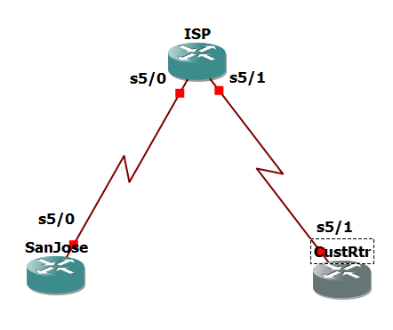

Router R1 (hostname SanJose)

conf t

hostname SanJose

!

interface Loopback0

ip address 10.1.1.1 255.255.255.0

!

interface Serial5/0

ip address 192.168.1.5 255.255.255.252

clock rate 128000

no shutdown

Router R2 (hostname ISP)

conf t

hostname ISP

!

interface Loopback0

ip address 10.2.2.1 255.255.255.0

!

interface Serial5/0

ip address 192.168.1.6 255.255.255.252

no shutdown

!

interface Serial5/1

ip address 172.24.1.17 255.255.255.252

clock rate 128000

no shutdown

Router R3 (hostname CustRtr)

conf t

hostname CustRtr

!

interface Loopback0

ip address 10.3.3.1 255.255.255.0

!

interface Serial5/1

ip address 172.24.1.18 255.255.255.252

no shutdown

SanJose(config)# router bgp 100

neighbor 192.168.1.6 remote-as 300

neighbor 192.168.1.6 remote-as 300

ISP(config)# router bgp 300

neighbor 192.168.1.5 remote-as 100

neighbor 172.24.1.18 remote-as 65000

network 10.2.2.0 mask 255.255.255.0

CustRtr(config)# router bgp 65000

neighbor 172.24.1.17 remote-as 300

network 10.3.3.0 mask 255.255.255.0

ISP# show ip bgp neighbors

SanJose# show ip route

SanJose# ping

**Press enter**

Target IP address: 10.3.3.1

**Press enter 3 time**

Extended commands [n]: y

Source address or interface: 10.1.1.1

**Press enter until success rate**

SanJose# ping 10.3.3.1 source 10.1.1.1

SanJose# show ip bgp

ISP(config)# router bgp 300

neighbor 192.168.1.5 remove-private-as

SanJose#ping 10.3.3.1 source lo0

SanJose# show ip bgp

ISP(config)# ip as-path access-list 1 deny ^100$

ISP(config)# ip as-path access-list 1 permit .*

ISP(config)# router bgp 300

ISP(config-router)# neighbor 172.24.1.18 filter-list 1 out

ISP# show ip route

CustRtr# show ip route

ISP# show ip bgp regexp ^100$

ISP# tclsh

foreach address {

10.1.1.1

10.2.2.1

10.3.3.1

192.168.1.5

192.168.1.6

172.24.1.17

172.24.1.18

} {

ping $address }